**Amrita Vishwa Vidyapeetham**

**Amrita School of Engineering, Coimbatore**

**Department of Computer Science and Engineering**

**Practice Question**

**--------------------------------------------------------------------------------------------------------------------------**

**Sub Code: 19CS211 Sub Title: COA**

**Roll No: CB.EN.U4CSE19453 Name: R.ABHINAV**

**Practice Lab Date: 08-03-2021**

1. Design an Up-Counter using the half-adder circuit

* **Verilog Code:**

module half_adder

(

i_bit1,

i_bit2,

o_sum,

o_carry

);

input i_bit1;

input i_bit2;

output o_sum;

output o_carry;

assign o_sum = i_bit1 ^ i_bit2; // bitwise xor

assign o_carry = i_bit1 & i_bit2; // bitwise and

endmodule // half_adder

* **Testbench :**

module half_adder_tb;

reg r_BIT1 = 0;

reg r_BIT2 = 0;

wire w_SUM;

wire w_CARRY;

half_adder half_adder_inst

(

.i_bit1(r_BIT1),

.i_bit2(r_BIT2),

.o_sum(w_SUM),

.o_carry(w_CARRY)

);

initial

begin

$monitor(r_BIT1, r_BIT2, w_SUM, w_CARRY);

r_BIT1 = 1'b0;

r_BIT2 = 1'b0;

#10;

r_BIT1 = 1'b0;

r_BIT2 = 1'b1;

#10;

r_BIT1 = 1'b1;

r_BIT2 = 1'b0;

#10;

r_BIT1 = 1'b1;

r_BIT2 = 1'b1;

#10;

end

endmodule

* **Snippets :**

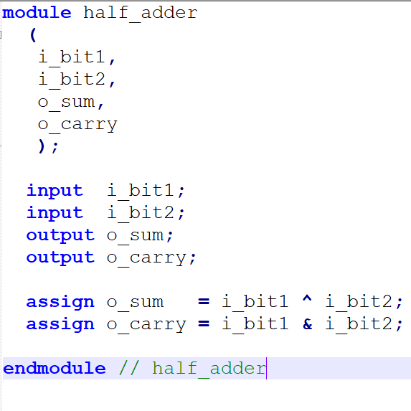

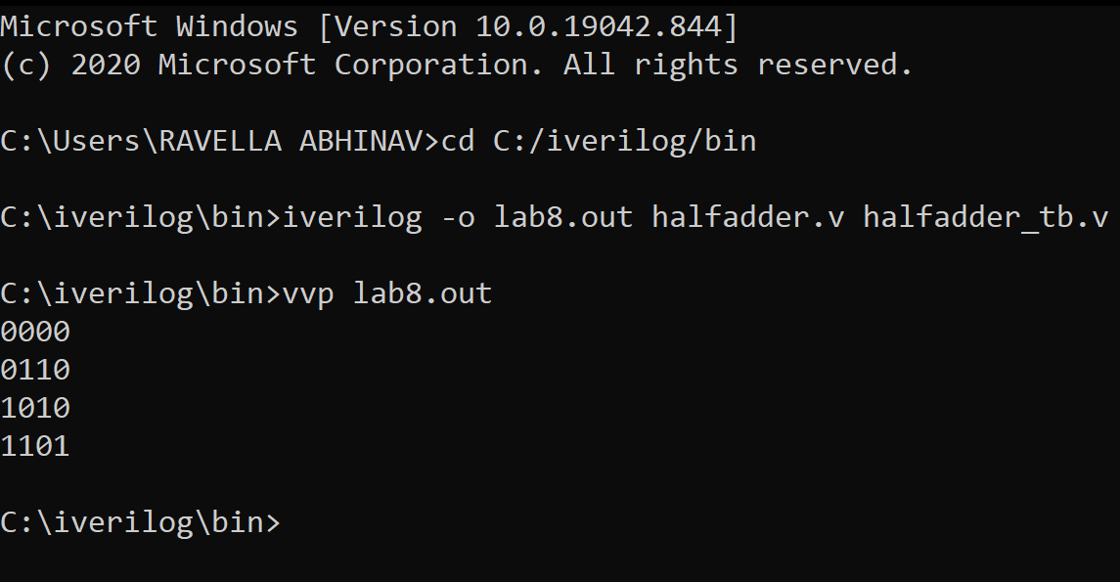

1. Design an Down-Counter using the half-subtractor circuit
2. Design an 2-bit ALU using the following circuit and logic

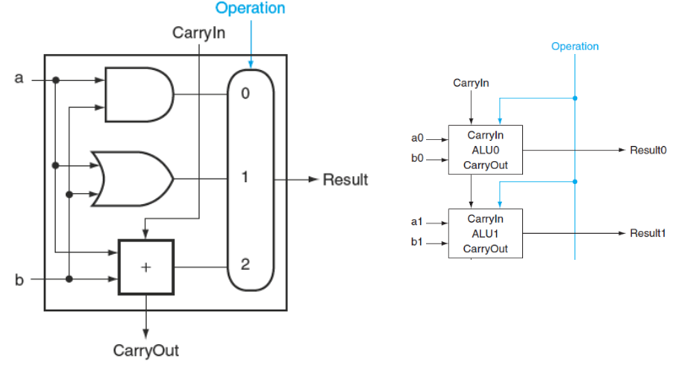

Based on the diagram above,

* the multiplexer on the right side select either a AND b or a OR b depending on whether the value of operation is 0 or 1.
* While the line in color control the multiplexer and the line is to distinguish from the lines containing data.

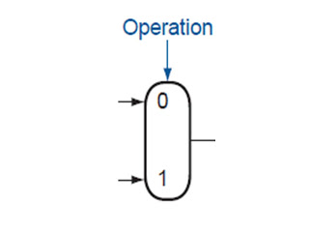

* CarryOut=(b.CarryIn)+ (a.CarryIn)+(a.b)+(a.b.CarryIn)
* Simplified :

CarryOut=(b.CarryIn)+(a.CarryIn)+(a.b)

* If (a.b.CarryIn) is true, all other three terms must be true and so the last term can be leaving out corresponding to the 4th line of the table)

|  |  |  |
| --- | --- | --- |
| INPUTS | | |
| a | b | CarryIn |
| 0 | 1 | 1 |
| 1 | 0 | 1 |
| 1 | 1 | 0 |
| 1 | 1 | 1 |

1. Write Verilog code for ALU. Write testbench Verilog code for the ALU for simulation and testing.

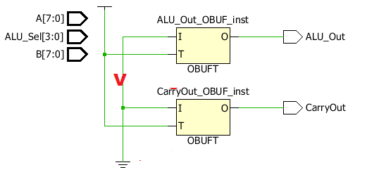

**Verilog Code :**

module alu(

input [7:0] A,B,

input [3:0] ALU_Sel,

output [7:0] ALU_Out,

output CarryOut

);

reg [7:0] ALU_Result;

wire [8:0] tmp;

assign ALU_Out = ALU_Result;

assign tmp = {1'b0,A} + {1'b0,B};

assign CarryOut = tmp[8];

always @(*)

begin

case(ALU_Sel)

4'b0000:

ALU_Result = A + B ;

4'b0001:

ALU_Result = A - B ;

4'b0010:

ALU_Result = A * B;

4'b0011:

ALU_Result = A/B;

4'b0100:

ALU_Result = A<<1;

4'b0101:

ALU_Result = A>>1;

4'b0110:

ALU_Result = {A[6:0],A[7]};

4'b0111:

ALU_Result = {A[0],A[7:1]};

4'b1000:

ALU_Result = A & B;

4'b1001:

ALU_Result = A | B;

4'b1010:

ALU_Result = A ^ B;

4'b1011:

ALU_Result = ~(A | B);

4'b1100:

ALU_Result = ~(A & B);

4'b1101:

ALU_Result = ~(A ^ B);

4'b1110:

ALU_Result = (A>B)?8'd1:8'd0 ;

4'b1111:

ALU_Result = (A==B)?8'd1:8'd0 ;

default: ALU_Result = A + B ;

endcase

end

endmodule

**Test Bench:**

module tb_alu;

reg[7:0] A,B;

reg[3:0] ALU_Sel;

wire[7:0] ALU_Out;

wire CarryOut;

integer i;

alu test_unit(

A,B,

ALU_Sel,

ALU_Out,

CarryOut

);

initial begin

A = 8'h0A;

B = 4'h02;

ALU_Sel = 4'h0;

for (i=0;i<=15;i=i+1)

begin

ALU_Sel = ALU_Sel + 8'h01;

#10;

end;

A = 8'hF6;

B = 8'h0A;

end

endmodule

**Snippets:**

